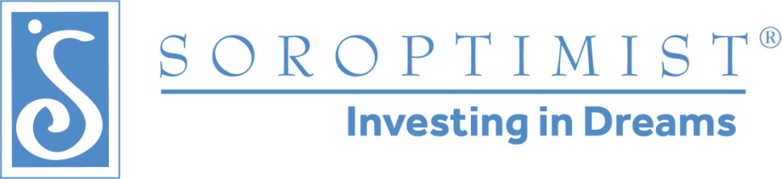

Soroptimist International of the Americas
North Atlantic Region’s Spring Conference 2022
Sponsorship Opportunities
April 22-24, 2022

SPONSORSHIP FORM

Sponsor’s Name/Business Name: _______________________________________________________________
Contact Person: _____________________________________________________________________________
Phone: ( ) _____________________________ Fax: ( ) ________________________________
E-mail: ____________________________________________________________________________________
Address: ___________________________________________________________________________________
City/State/Zip: ______________________________________________________________________________
Sponsorship Level: __________________________________________________________________________
(See attached "Selections & Benefits” page for a description of level benefits)

$500 “Empowerment” Sponsor
$250 “Opportunity” Sponsor
$100 “Collective Impact” Sponsor

Sponsor's Signature/Title: _________________________________________ Date: ____________________

*Please mail this form with check to be received by March 15th to:
SIA North Atlantic Region
c/o Karen Gehers
PO Box 222
Kreamer PA 17833

(ATTN: “Spring Conference Sponsorship”)

PLEASE RETAIN A COPY OF THIS FORM FOR YOUR RECORDS
Soroptimist International of the Americas North Atlantic Region is a 501(c)(3) charitable organization with EIN 23-2334555.

THANK YOU for your support of SIA North Atlantic Region!

Soroptimist International of the Americas
North Atlantic Region’s Spring Conference 2022
Sponsorship Opportunities
April 22-24, 2022

SELECTIONS & BENEFITS

“Empowerment” Sponsor - $500

- “Thank You” and link to your business website or Facebook page on Region’s website (through 12/31/2022)
- Verbal "Thank You" at Saturday Live Your Dream Award Luncheon and Banquet Dinner
- Ability to include business card and/or other promotional materials in Conference goody bags to attendees
- Name & Logo listed on Conference Sponsor Boards as “Empowerment” Sponsor – largest on board
- Name & Logo listed on Sponsor slide in Conference General Sessions as “Empowerment” Sponsor
- Name & Logo listed on Conference printed insert as "Empowerment” Sponsor

“Opportunity” Sponsor - $250

- “Thank You” and link to your business website or Facebook page on Region’s website (through 12/31/2022)
- Ability to include business card and/or other promotional materials in Conference goody bags to attendees
- Name & Logo listed on Conference Sponsor Boards as “Opportunity” Sponsor
- Name & Logo listed on Sponsor slide in Conference General Sessions as “Opportunity” Sponsor
- Name listed on Conference printed insert as "Opportunity” Sponsor

“Collective Impact” Sponsor - $100

- Name listed on Conference Sponsor Boards as “Collective Impact” Sponsor
- Name listed on Conference printed insert as "Collective Impact” Sponsor



