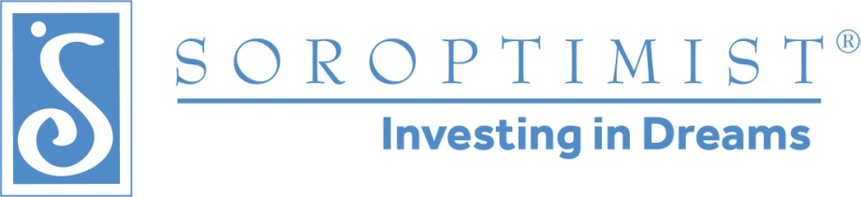
Soroptimist International of the Americas North Atlantic Region
P.O. Box 222
Kreamer, PA 17833

Dear Friend,

There are many issues facing society, but one that is prevalent worldwide is the lack of access to education for women and girls. In 2000, the United Nations established its Girls’ Education Initiative (UNGEI) - a partnership of organizations committed to narrowing the gender gap in primary and secondary education and seeking to ensure that all children complete primary schooling, with girls and boys having equal access to free, quality education. In 2014, the Bill & Melinda Gates Foundation launched a new Grand Challenge: Putting Women and Girls at the Center of Development focusing on how to effectively reach and empower the most vulnerable women and girls to improve health and development – including economic – outcomes as well as gender equality. It is not a coincidence that many organizations are focusing on the plight of women and girls.

Since 1921 Soroptimist International, a 501(c)(3) non-profit organization with 80,000 members in over 100 countries & territories worldwide, has improved the lives of women and girls. The clubs of Soroptimist International of the Americas North Atlantic Region (SIA NAR) have provided service and financial assistance to programs that support women and girls. In addition, SIA NAR provides financial “Live Your Dream” awards to women who are heads of households and pursuing a higher education. Our mission as philanthropic, community-minded women is to provide women and girls with access to the education and training they need to achieve economic empowerment.

The weekend of April 22-24, SIA NAR will hold its annual Spring Conference where over 100 members and guests will come together to celebrate the bright past and brilliant future of Soroptimist. At this conference, we will celebrate 100 years of Soroptimist, and honor our Region Live Your Dream Award recipients and hear their inspirational stories.

NOW IS AN EXCITING TIME TO PARTNER WITH US AS A CONFERENCE SPONSOR!

Levels are $100, $250 and $500

Choose the level that has benefits that suit your business

Sponsorship materials are enclosed for your consideration. Sponsor levels provide advertising for your business and start as low as $100. A few levels include links to your business website or Facebook page from our SIA NAR website and allow you to provide promotional items to include in attendee goody bags.

For more information about these Conference sponsorships, please contact Tracy Scala, SIA NAR Co-Treasurer, at (860) 299-5113 or e-mail her at tracyscala@sbcglobal.net.

Thank you in advance for your consideration! We look forward to partnering with you!

Gratefully yours,

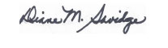
Diane M. Savidge
Governor 2020-2022, Soroptimist International of the Americas North Atlantic Region

