August 9, 206  SCHEDULE CHANGE  Live Your Dream 2026  NAR Chair, Linda Wakim | 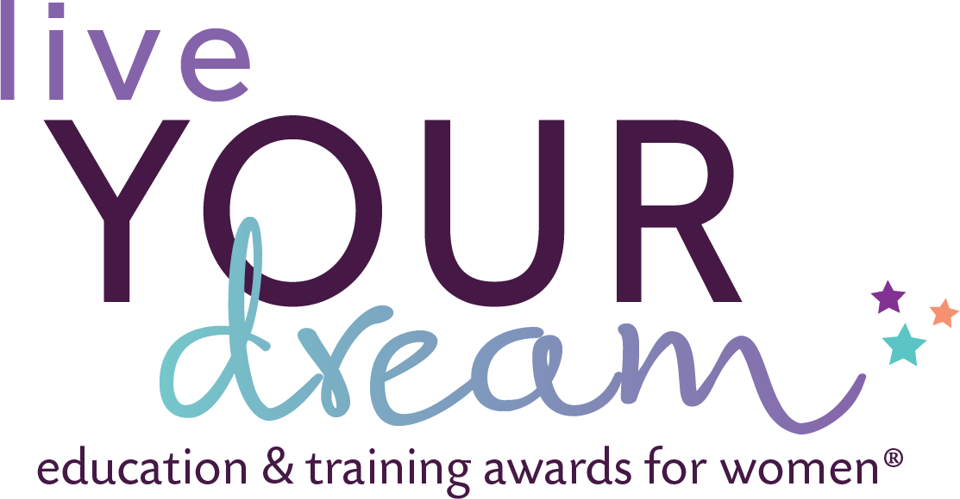

Ladies, please be aware that dates for Sessions 3, 4 and 5 have changed. I am unavailable until then, due to travel. There will not be a LYD Training session until 8/20. The Zoom Link below is for all LYD sessions.

ZOOM LINK for both calls: LYD ZOOM
https://birdzi.zoom.us/j/88634878968?pwd=4fjlTksaCPL3XLkS9wnaqN3znmYoqk.1
Meeting ID: 886 3487 8968
Passcode: 975814

Session #3: Accessing the LYD Portal & Application Review
Objective: Log-into the LYD application portal for your club, review application(s), return to applicant, if necessary, and download the application as a pdf at all steps in the process. Progress check #1 on communication plans and social media postings.
- Introduction to the Portal, first time login VIDEO
- If you need help accessing the portal this VIDEO will be helpful.
- Important step, saving applications, VIDEO
- For further assistance, between our sessions, you can reach out to our SIA team. The respond within 24-48 hours. lydawards@soroptimist.org
Thursday 8/20, 8-9 PM Eastern and Monday 8/25 6-7 PM

Session #4: Hosting an Application Workshop
Objective: Discuss “Why,” “Where,” and “When” to host an application workshop. Select materials for the workshop, communicate to eligible women, recruit members who can help with the workshop. Progress check #2 on communication plans and social media postings.
Thursday, 8/27, 8-9 PM Eastern and Monday, 8/31, 6-7 PM Eastern

Session #5: Application Tracking and Applicant Out-Reach
Objective: Feel comfortable with reviewing applications and tracking through the process. Plan to contact individual applicants for clarification and/or revisions needed. Progress check #2 on communication plans and social media postings. Progress check on the number of applications submitted.
Tuesday, 9/15, 6-7PM Eastern and Thursday, 9/17, 8-9PM Eastern

Additional Sessions will be planned as needed.

